RESEARCH ARTICLE |  | OPEN ACCESS

Automated Retinal Disease Classification from OCT Images Using a Lightweight CNN–SE Architecture

Parth R. Dave¹., Nikunj H. Domadiya², and Jaiwal Patel³

¹ Research Scholar, Gujarat Technological University, Ahmedabad, Gujarat, India
^{1,2} Assistant Professor, Computer Engineering Department, L. D. College of Engineering, Ahmedabad, Gujarat, India
³ Gems New Millenium School, Dubai
Corresponding author: Nikunj H. Domadiya (e-mail: domadiyanikunj002@gmail.com), Author(s) Email: Parth R. Dave (e-mail: parthdave.ce@ldce.ac.in) Jaiwal Patel (e-mail: ujaiwal@outlook.com)
Abstract In recent times Artificial Intelligence is playing the important role in many fields of medical science. Ophthalmology is a field of medical science in which the disease related to front and back end of the eye is measured and according to that the treatment is provided. The backend of the eye is called retina which is responsible to send the electromagnetic signals to the brain through optic nerve system. Optical Coherence Tomography (OCT) is an imaging method that allows retina specialists to examine the internal structure of the eye in detail. This method contributes to the accurate identification of different retinal disorders: Age-Related Macular Degeneration (AMD), Central Serous Retinopathy (CSR), Macular Hole (MH), Diabetic Retinopathy (DR), Drusen, Diabetic Macular Edema (DME) and Choroidal Neovascularization (CNV). However, manual analysis of OCT images is really time-consuming and subjective according to the domain knowledge of the specialist. Applying deep learning for the automatic classification of retinal diseases from OCT images is valuable for achieving timely, reliable, and early-stage detection of the anomalies. On the top of it many anomalies are having feature overlapping conditions which have to be addressed in detail. To improve the current diagnostic process, this study presents a lightweight CNN-based model for the automated classification of retinal OCT images. The present study develops a computationally efficient model that provides high diagnostic accuracy without the use of complex architectures or transfer learning techniques. In this study, we propose an effective thirteen-layer Convolutional Neural Network (CNN) incorporating Squeeze-and-Excitation (SE) blocks, along with data augmentation and the Adam optimizer. The proposed framework was trained and assessed on OCT-C8 and OCT2017 dataset, which comprises the seven and three classes of abnormalities consecutively and one class as a normal retinal structure in both the datasets. Our proposed approach achieved 97.00% and 99.00% of accuracy while testing on the OCT-C8 and OCT2017 datasets consecutively. The proposed CNN-SE model is a generalized model which achieves faster and accurate inference through a lightweight design. Furthermore, cross-dataset validation, in which the model was trained exclusively on OCT-C8 and directly tested on the independent OCT2017 test set without retraining or fine-tuning, achieved 98.74 ± 0.11% accuracy across five random seeds. The proposed CNN-SE model therefore demonstrates strong classification performance and cross-dataset generalization while maintaining a lightweight design for efficient inference.
Keywords Convolutional Neural Network; Artificial Intelligence; Machine Learning; Deep Learning; Optical Coherence Tomography
- Introduction
Optical Coherence Tomography (OCT) is a valuable imaging technique used for the early detection of retinal diseases. It generates high-resolution tomographic images of retinal tissue that enables accurate detection of structural abnormalities within the retina part and macula part. Retinal diseases sometimes may result into irreversible vision loss and therefor the early detection of the abnormalities is essential. Retinal OCT imaging is widely used in ophthalmology to assist in treatment planning and to monitor the success of treatments such as laser therapy, eye injections, and surgical interventions. There are several factors that can lead to retinal disorders, such as genetic defects, stress, aging, lack of physical activity, excessive screen exposure, and unhealthy eating habits. As a result, retinal diseases are becoming more common, making it essential to carry out fast, precise, and consistent evaluations. Automated retinal OCT image classification techniques can be helpful as a suggestive system to the doctors which provide impartial, reliable and diagnostic consistencies for pointing out the abnormalities.
Conventional machine learning algorithms use texture-based detailing retrieved from images to represent local or global information. Various feature extraction techniques such as Local Binary Pattern (LBP)[1] , Histogram of Oriented Gradients (HOG)[2], Gray-Level Co-Occurrence Matrix (GLCM)[3] , edge detection, and shape detection are applied to obtain a discriminative feature vector. The extracted feature representation is then fed into supervised learning classifiers, including Artificial Neural Networks (ANN)[4] and Support Vector Machines (SVM) [5], or other classifiers to perform the final image classification. However, one major limitation of classical machine learning approaches is that they depend on manually extracted features instead of learning the features directly from the data. Since the image representation relies only on predefined feature descriptors, some important information from the original image may be lost during the feature extraction process. This loss of information can affect how well the model understands the data and may lead to lower accuracy and reduced overall performance of the classification system.
In recent years, advanced computational techniques have gained significant attention in the field of computer vision, as it can automatically extract complex patterns and important features from input images without requiring manual feature engineering. Convolutional Neural Networks (CNNs)[6], in particular, have significantly changed the way image-related tasks are approached which is actually outperforming various traditional and shallow learning methods in several aspects. Deep learning is not confined to image classification; it has also been effectively utilized in visual recognition, medical imaging, multimedia analysis, audio understanding, and text processing. These diverse applications emphasize its flexibility and growing importance across the various real-world applications.
CNNs learn important spatial characteristics and structural relationships in input images by employing successive convolutional and pooling layers. As the data passes through these consecutive layers, increasingly relevant features are extracted and subsequently forwarded to the dense layers where the ultimate classification decision is generated. The fully connected part may consist of multiple hidden units just before reaching to the final output stage. The last layer consists of output nodes representing the different categories defined in the dataset for classification which is enabling the model to accurately assign the input sample to its corresponding category. Appropriate activation functions, model parameters, and hyperparameters are chosen to enhance the learning performance of the network and enhance its generalization capability and robustness on unseen test dataset. In addition to that several techniques are employed to manage problems such as underfitting and overfitting. These methods enable the model to learn efficiently from the training data while ensuring consistent performance when testified on the test dataset.
In past few years, computer vision has witnessed remarkable growth, supported by the emergence of several pre-trained models capable of extracting meaningful information from complex visual data, including NASNetMobile [7], AlexNet [8], VGG16 [9], VGG19[9], ResNet50[10], and GoogLeNet [11], transformer models and lightweight models. These architectures are trained on large and diverse image databases, which helps them learn diverse visual features and patterns. Owing to the rich feature representations acquired during training, these models can be effectively applied to extract features from new image datasets. This is commonly done by removing the final fully connected layer(s) and using the remaining layers of the network to obtain meaningful and detailed features from the input images. The remainder of this manuscript is structured into five sections. Section II reviews the existing literature, while Section III describes the proposed methodology. Section IV presents the experimental setup and discusses the obtained results. Finally, Section V concludes the study and outlines potential directions for future research.
Automated OCT image analysis plays a crucial role as a suggestive system between patient and a doctor to identify the anomalies in a grater detailed manner. Many efforts have been carried out over the years to achieve this by applying conventional and contemporary machine learning algorithms with various techniques.
P. P. Srinivasan et al. [12] performed image reshaping, noise reduction and cropping the retinal images to extract Histogram of Oriented Gradients (HOG) descriptors [2]. For multi-class classification, a Support Vector Machine (SVM) classifier [5] was used with a one-versus-one strategy, resulting in three linear SVM classifiers corresponding to the three dataset classes: AMD, DME and Normal. The retinal image dataset used in the study was locally developed using OCT images collected from patients with different retinal disorders. Y.-Y. Liu et al. [13] presented proposed a traditional OCT image classification method using multi-resolution and PCA-based[14] LBP features. An SVM classifier was employed to classify MH, ME, and AMD from a locally collected dataset. Alsaih K et al. [15] proposed a conventional OCT classification approach using Histogram of Oriented Gradients (HOG) [2] and Local Binary Patterns (LBP) [1] features with PCA for feature reduction. The optimized features were classified using an Support Vector Machine (SVM) [5] on a locally collected dataset.
On the other hand, several advanced techniques have been proposed for the classification of retinal OCT images. L. Huang et al[16] developed a layer-based CNN that learned features from individual retinal layers for OCT image classification. The extracted features were combined using transfer learning, achieving improved performance on the OCT2017 [17] and HUCM [16] OCT image datasets. J. Kim and L. Tran [18] proposed a two-stage deep learning model for OCT image classification. U-Net-based ROI extraction and image alignment enhanced feature learning, leading to better accuracy than L. Huang et al. [16] on OCT2017 [17] dataset. Shengyong Diao et al. [19] proposed CM-CNN and CAM-UNet for AMD classification from OCT images. Their approach improved region localization and achieved promising performance. Hassan E. et al. [20] proposed the EOCT framework, combining ResNet-50 [10] feature extraction with a Random Forest classifier for OCT image classification. The model, trained using SGD and Adam, achieved state-of-the-art performance. On OCT2017 dataset [17]. For the automatic categorization of normal and AMD retinal scans, Lee [21] suggested a 21-layer VGG16-based convolutional neural network trained on 2.6 million EMR-linked OCT pictures. By combining scan-level predictions, the model attained 87.63\% image-level, 88.98\% OCT-level, and 93.45\% patient-level accuracy (AUROC up to 97.46\%). Nevertheless, the framework's clinical generalizability was constrained by its binary classification capability, lack of external validation, and training using data from a single institution and OCT instrument.
In [22], authors proposed OCTx, an ensemble deep learning model for four-class OCT image classification. It achieved strong performance but was evaluated on a limited dataset. In [23], the authors presented a CNN model using ImageNet pre-trained weights for three-class retinal OCT image classification. Fine-tuning and ensemble learning increased the classification accuracy from 68.17% to 92.89%. In [24], the authors evaluated AlexNet, VGG, Inception, and ResNet for retinal OCT image classification. The Inception model with RMSprop achieved the best results, reaching 95.53% accuracy and an F1-score of 0.93687. In [25], the authors applied NasNetMobile [7] to classify eight retinal diseases using the OCT-C8[26] dataset. Among the tested optimizers, SGD delivered the best results with 97% accuracy and stable convergence within 22 epochs.
Jannat et al. [27] presented OCT-SelfNet is a SwinV2-based self-supervised framework that combines masked autoencoder pre-training with cross-dataset data fusion, achieving 99% classification accuracy with high AUC-ROC, AUC-PR, and F1-score. However, its evaluation is limited to binary classification (AMD vs. Normal), restricting its applicability to multi-class retinal disease diagnosis. Dave and Domadiya et al. [28] formulated a CNN-based model for retinal OCT image classification. Using hybrid pooling, data augmentation, and learning rate decay, the model achieved 98.75% accuracy on the OCT2017 [17] dataset. A thorough analysis of earlier machine learning and deep learning approaches used for OCT image classification is summarized in Table 1.
Even while current approaches have demonstrated promising outcomes, many still rely on computationally costly deep learning models or intricate preprocessing. Several methods are challenging to apply effectively because they call for distinct stages for feature extraction or segmentation. Furthermore, their robustness and generalizability in practical clinical applications are constrained by evaluation on small datasets or illness classifications.
To bridge this gap this paper suggests a CNN-based model for retinal OCT image categorization utilizing the OCT-C8 [26] and OCT2017 [17] datasets in order to overcome these drawbacks. For efficient feature learning, the network uses 13 convolutional layers with SE blocks; training stability and generalization are enhanced by data augmentation and the Adam optimizer. With minimal computing complexity, the suggested model provides excellent classification performance.
The proposed approach makes several key contributions to the field. The methodological contribution of the proposed model lies in the task-specific integration of Squeeze-and-Excitation (SE) blocks within a compact 13-layer CNN architecture designed for retinal OCT classification. Rather than relying on a conventional pretrained backbone with an added SE module, the proposed network combines progressive convolutional feature extraction, channel-wise feature recalibration, global average pooling, and dropout within a unified architecture. Despite incorporating these components, the model contains only approximately 375,000 trainable parameters, enabling a compact network structure while retaining the capacity to learn diagnostically relevant retinal features. The effectiveness of this configuration is further evaluated through classification performance, cross dataset validation, ablation experiments, and computational-efficiency analysis.

Method
The detailed architecture of the proposed framework is shown in Fig. 1. The proposed framework mainly has five working modules. The first one is the input datasets, secondly the preprocessing and augmentation, thirdly a raw CNN architecture with SE blocks, the second last module is selecting a proper optimizer for the multiclass classification and the last one is the evaluation of the model using two different datasets.

Table 1:Overview of Existing Approaches for Retinal OCT Image Classification
Reference | Category | Dataset Used | Key Methodology | Limitation
Y.-Y. Liu et al. [13] | Machine Learning | Local dataset | SVM classifier using both global and local image features | Classification performance is highly dependent on accurate feature extraction and image alignment.
Alsaih K et al. [15] | Machine Learning | Local dataset | HOG, LBP, and PCA features combined with an SVM classifier | Relies on handcrafted feature engineering, which may reduce adaptability to diverse datasets.
L. Huang et al. [16] | Deep Learning | OCT2017, HUCM | Layer-guided CNN developed using transfer learning | Requires retinal layer segmentation before classification, increasing preprocessing complexity.
J. Kim and L. Tran [18] | Deep Learning | OCT2017 | U-Net-based preprocessing with image rotation followed by binary CNN classifiers | Multiple preprocessing stages increase computational complexity and execution time.
S. Diao et al. [19] | Deep Learning | Not specified | CM-CNN integrated with CAM-Unet for retinal image analysis | Separate segmentation and classification networks make the framework more complex.
Hassan E et al. [20] | Hybrid Learning | OCT2017 | ResNet-50 used for feature extraction followed by a Random Forest classifier (EOCT) | Hybrid architecture requires additional training effort and higher implementation complexity.
D. Paul et al. [22] | Ensemble Deep Learning | OCTx, OCT2017 | Ensemble of multiple deep learning models for retinal OCT classification | Limited training data may restrict the model's ability to generalize to unseen clinical images.
Yang J et al. [23] | CNN Ensemble | OCT2017 | Ensemble learning strategy combining multiple CNN models | Increased memory usage and computational requirements during training and inference.
Stanojević et al. [24] | Deep Learning | OCT2017 | Comparative evaluation of CNN models with InceptionV1 showing the best performance | High computational demand limits its suitability for real-time applications.
Madhumithaa S et al. [25] | Deep Learning | OCT-C8 | NasNetMobile architecture optimized using the SGD optimizer | Computationally demanding, making deployment on resource-limited systems challenging.
Dave and Domadiya et al. [28] | Deep Learning | OCT2017 | CNN architecture incorporating hybrid pooling with an optimized training strategy | Validation was limited to four retinal disease categories, reducing its broader applicability.

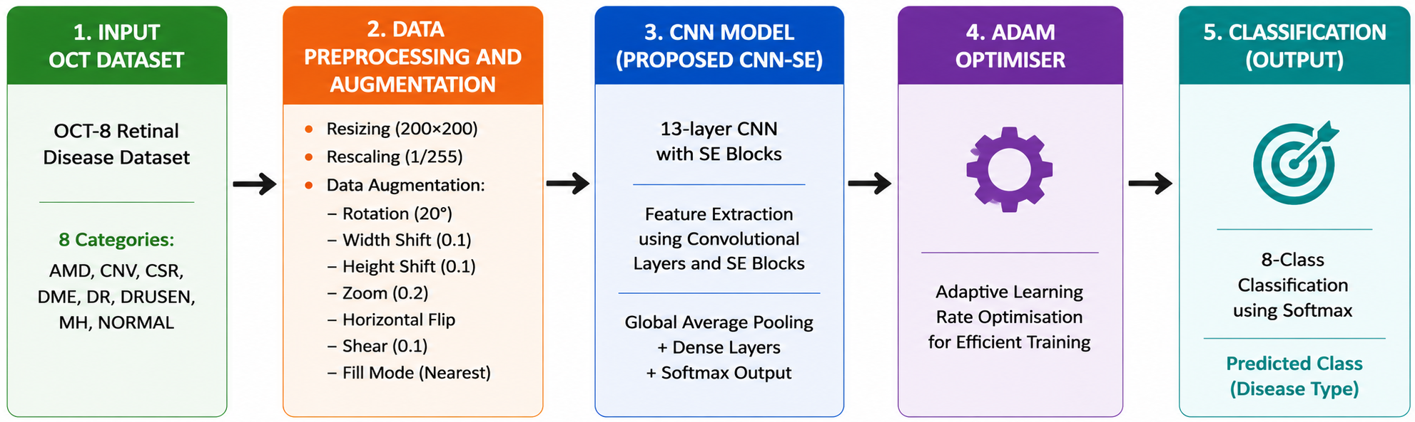
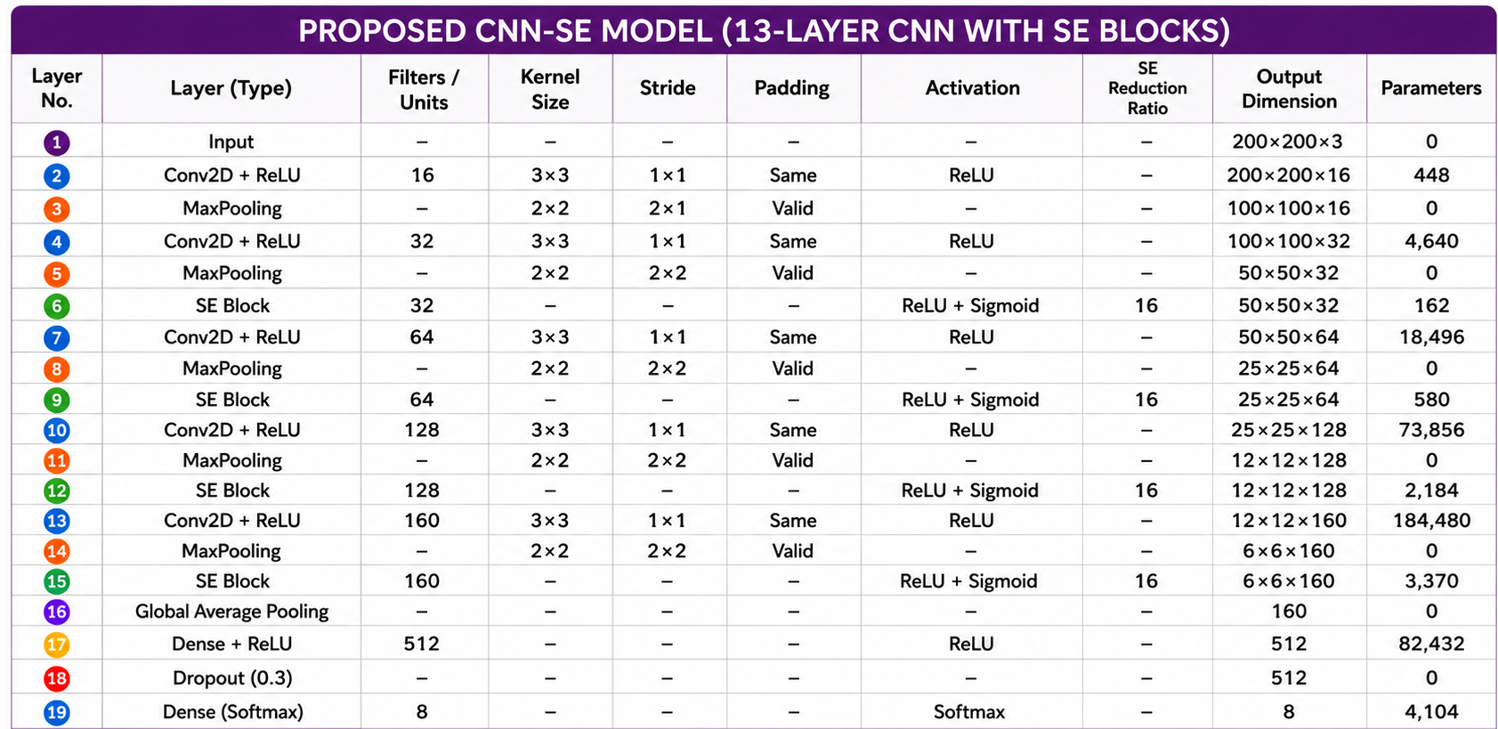
Fig. 1. Proposed CNN Model (OCT-C8: 8 Class, OCT 2017: 4 Class)

- Data Preparation
The OCT-C8 dataset [26] contains 8 classes: Drusen, MH, AMD, CNV, CSR, DME, DR, and Normal. There are 2,800 validation (350 per class) and test photos (350 per class) and 18,400 training images (2,300 per class). Feature extraction is more difficult because each image has a resolution of 96 dpi with a 24-bit depth and contains noise and different intensity patterns.
The OCT2017 dataset [17] comprises 83,484 training photos, 968 test images (242 per class), and 32 validation images, divided into four classes: CNV, DME, Drusen, and Normal. While example samples, the training images vary in size and contain noise. The publicly available OCT dataset was used as provided by its original authors, with images collected from different patients. Before model training, the images were resized to 200 × 200 pixels using bilinear interpolation, converted to RGB format, and normalized to the range [0,1]. No additional quality screening or duplicate removal was performed, as the dataset was used in its original curated form.

- Data Augmentation
By transforming the source images, image augmentation creates a variety of training examples that aid CNN in learning minor differences across comparable classes [29]. This lessens overfitting, increases generalization, and improves feature representation. Table 2 lists the augmentation settings utilized in the suggested strategy, which creates augmented images during training without storing them permanently.
To improve the model’s ability to generalize while preserving the anatomical characteristics of retinal OCT images, augmentation was applied exclusively to the training set. The training images were subjected to controlled transformations, including horizontal flipping, small-angle rotation, limited horizontal and vertical translation, moderate zooming, and mild shearing, to introduce realistic variations in image appearance and spatial alignment. These transformations increase the diversity of the training distribution and encourage the network to learn stable, discriminative retinal features rather than relying on specific image orientations or local patterns. Vertical flipping and excessive geometric transformations were deliberately avoided because they may alter the natural arrangement of retinal layers and produce anatomically unrealistic pathological patterns. The augmented samples were generated online during training, so the original images were not permanently duplicated and no augmentation was applied to the validation or test sets. Representative transformed images were also visually inspected to verify that retinal-layer continuity, tissue boundaries, and disease-related morphological structures remained identifiable after augmentation..
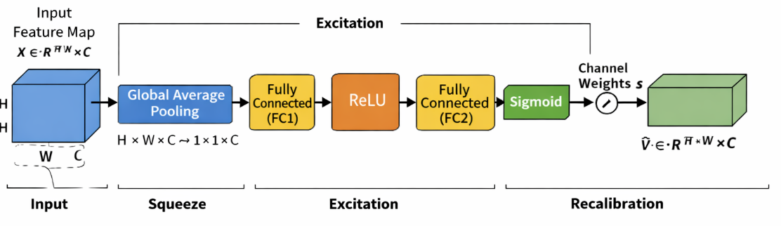
Fig. 2. Architecture of SE block

Table 2. Configuration Details of Image Transformation Techniques
Parameter Name | Parameter Value
Pixel value normalization | 1./255
Rotation angle | 20
Horizontal shift | 0.1
Height shift | 0.1
Zoom factor | 0.2
Horizontal flipping | True
Shear intensity | 0.1
Fill mode | Nearest

- Squeeze-and-Excitation Blocks
The Squeeze-and-Excitation (SE) block[26] by finding the most informative feature channels and simulating channel-wise dependencies, it enhances CNN feature learning. It produces more selective representations of features by enhancing significant traits while suppressing less important ones. The overall architecture for SE block is depicted in Fig. 2.
The operation of the SE block is divided into three key stages: squeeze, excitation, and recalibration. In the squeeze stage, global average pooling is applied to the input feature map $X ∈R^{H* W* C}$ to produce a channel-wise descriptor. In this stage, each channel's spatial dimensions H×W are reduced into one representative value, effectively capturing the global distribution of feature responses. Mathematically, the output of the squeeze operation for the Cth channel is computed as Eq. (1)[30] where Z_{c}​ represents the aggregated statistic of the Cth channel. This descriptor encodes the global contextual information and reflects the overall importance of each channel.

$$Z_{c}=\frac{1}{H*W}\sum_{i=1}^{H}{\sum_{j=1}^{W}{X_{c}\left(i,j\right)}}$$ | (1)

After the squeeze stage, the excitation module learns the importance of each channel using two dense layers with a bottleneck structure. ReLU [31] and sigmoid activations generate normalized channel-wise weights that emphasize informative features while reducing computational cost. This process can be expressed as Eq. (2)[30]

$$S= σ(W_{2}*δ\left(W_{1}*z\right))$$ | (2)

where “z” is the squeezed vector, W₁​ and W₂​ are the learnable parameters of the fully connected layers, δ denotes the ReLU [31] activation, and σ represents the sigmoid function.
In the final feature refinement step, the learned channel parameters are applied to the actual feature map. Each feature channel is scaled based on its assigned importance value, enabling the network to highlight the most meaningful features while minimizing the influence of less important ones. This is given by Eq. (3).

$$\tilde{X}=s_{c}*X_{c}$$ | (3)
where S_{c}​ is the learned weight for the Cth channel. This feature refinement process improves the network's ability to learn meaningful channel-wise information by giving greater emphasis to the most pertinent attributes while simultaneously diminishing the impact of less beneficial ones. As a result, the model achieves better classification performance with only a small increase in computational cost.
The global average pooling of SE block can be depicted by Eq. (4)[30]

$G_{c}= \frac{1}{H x W}\sum_{i=1}^{H}{\sum_{j=1}^{W}{X_{c}(i,j)}}$ (4)

- Adam Optimizer
The Adam optimizer is a widely used method for training deep learning models due to its ability to perform well in a variety of scenarios. It integrates the concepts of adaptive learning and momentum, allowing the model to adjust how much each parameter is updated during training. Instead of using the same learning rate for all parameters, Adam adapts it based on the behavior of the gradients, which helps the model learn more efficiently and with better stability. Eq. (5)[32] computes the first raw moment vector using the first hyperparameter (typically 0.9) to maintain an exponentially decaying average of past gradients that tracks directional momentum.
$m_{t}= β_{1}m_{t-1}+(1-β_{1})g_{t}$ (5)

Eq. (6)[32] calculates the uncentered second raw moment vector using the second hyperparameter (typically 0.999) to track gradient variance by maintaining an exponentially decaying average of squared gradients.
$v_{t}= β_{2}v_{t-1}+(1-β_{2})g_{t}^{2}$ (6)

Eq. (7)[32] yields the bias-corrected first moment estimate by dynamically adjusting the time step, which compensates for the moving average's initial bias toward zero.
${\hat{m}}_{t}= \frac{m_{t}}{1-β_{1}^{t}}$ (7)
Eq. (8) [32]derives the bias-corrected second raw moment estimate by adjusting for the time step, correcting the initial zero-bias in variance tracking during early iterations.
${\hat{v}}_{t}=\frac{v_{t}}{1-β_{2}^{t}}$ (8)
Eq. (9)[32] updates the model parameters by adjusting the learning rate with the ratio of these bias-corrected moments, providing adaptive step sizes stabilized by a small constant.

$θ= θ- α* \frac{m}{\left(\sqrt{v}\right)+\left(∈\right)}$ (9)
where m captures the average of past gradients and v represents the average of their squared values. These estimates are continuously updated during training, helping the optimizer adapt to the shape of the loss function. Because of this adaptive behaviour, Adam tends to converge faster and requires less manual tuning compared to traditional optimization methods. It performs particularly well in problems involving large datasets, high-dimensional pameters, or noisy gradients

- CNN Architecture
The proposed CNN processes 200×200×3 OCT images through successive convolution and max-pooling layers to learn hierarchical image features. SE blocks are incorporated after each stage to emphasize important feature channels while suppressing less relevant ones. The gradual increase in filters enables effective feature extraction, leading to improved retinal OCT image classification. The extracted feature maps are condensed using global average pooling and passed to a 512-neuron dense layer with 0.3 dropout to improve generalization. A softmax layer then produces the final class predictions for the OCT-C8 and OCT2017 datasets.
A 2x2 max-pooling procedure follows each convolutional layer to preserve the most informative features while reducing the size of the feature map by keeping just the strongest activations. As seen in Fig. 3 and Eq. (10)[33][34], this increases the computing efficiency and aids in the model’s learning of more robust features.
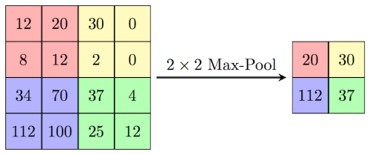
Fig. 3. Illustration of 2x2 max pooling

$$MaxPool(x)=max⁡(x_{ij}) _{1≤i≤k,1≤j≤k}$$ | (10)
The ReLU [31] activation function is used throughout the CNN to introduce non-linearity by retaining positive values and suppressing negative ones. Its computational efficiency and ability to mitigate the vanishing gradient problem enable faster and more stable network convergence. The mathematical equation is depicted by Eq. (11) [31]
F(x) = max(x, 0) | (11)
The 6×6×160 feature maps are compressed by global average pooling into a 1×1×160 feature vector following the final convolution and max-pooling stage, and then they are sent to a 512-neuron dense layer for discriminative feature learning. To lessen overfitting and enhance model generalisation, a dropout rate of 0.3 is used during training. Eight neurons are used in the last output layer for the OCT-C8 [23] dataset and four neurons for the OCT2017 [15] dataset, with each neuron representing a distinct class to generate the final classification results. The last layer uses the softmax activation function to calculate the likelihood of each output class. Using these probabilities, the framework assigns the input picture to the class with the greatest confidence score. The suggested model minimizes the discrepancy between the true and predicted class labels during training by using categorical cross-entropy loss for multi-class classification.
The equation, Eq. (12)[8][10] , represents a 2D convolutional layer where a filter matrix with a bias value slide across an input image to calculate a weighted sum at each overlapping region. This mathematical operation extracts localized spatial features from the input data to produce a specific coordinate pixel value within the output feature map, as detailed in Eq. (12)[8][10].

$Y\left(i,j\right)= \sum_{m=0}^{K-1}{\sum_{n=0}^{K-1}{X\left(i+m,j+n\right)*W\left(m,n\right)+b}}$ (12)

The spatial dimensions of the output feature map after convolution are calculated Eq. (13)[8], determines the final spatial output size of a feature map by adding twice the padding (P) to the input dimension (N) and subtracting the kernel size (K). This result is then divided by the stride rate (S), rounded down to the nearest integer using the floor function, and increased by one to account for the final filter placement, as outlined in Eq. (13)[8].

$O= \left\lfloor \frac{N-K+2P}{S}\right.\left.\frac{ }{ }\right\rfloor +1$ (13)
The mathematical formulation of the softmax function is presented in Eq. (14). The function transforms the raw output values of the network into normalized probability scores ranging from 0 to 1, with the total probability across all classes equal to one. In Eq. (14), Z represents the input vector received by the output layer, and j refers to an individual output neuron, where j = 1, 2, ..., K.
$${σ(z)}_{j}= \frac{e^{{(z)}_{j}}}{\sum_{k=1}^{K}{e^{{(z)}_{k}}}}$$ | (14)
The dense layer transforms the extracted features into a higher-level representation as shown in Eq. (15)[9] , where (W) denotes the weight matrix, (x) represents the input feature vector, (b) is the bias, and (f(.)) denotes the ReLU activation function.This transformation enables the network to learn complex feature representations for accurate classification
$h=f\left(Wx+b\right)$ (15)
As discussed, earlier dropout cand be denoted by Eq. (16)[35] which reduces the overfitting to make a model generalized one.
$h_{drop}=r ⨀ h$ , $r ∼Bernoulli(p)$ (16)

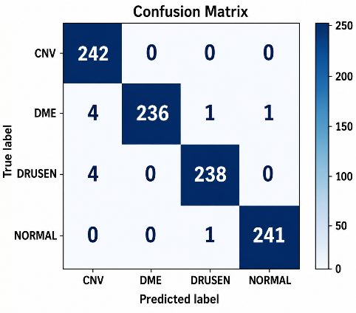 | 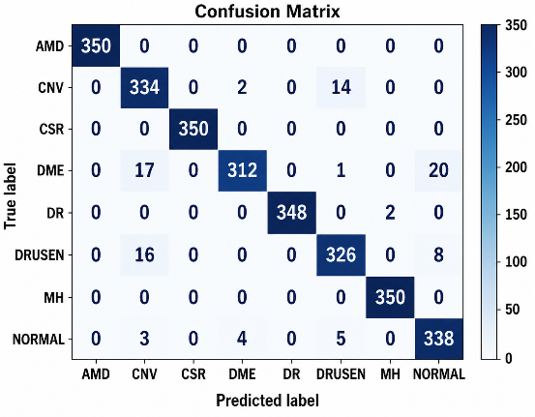
Fig. 4. Confusion matrix for OCT2017(left) and OCT-C8(right) test datasets

Evaluation Setup and Experimental Findings
The proposed CNN–SE model was implemented in Python 3.12.13 using TensorFlow 2.21.0, Keras, scikit-learn, and Matplotlib on an AMD Ryzen 7 5700G (3.80 GHz) CPU with 16 GB RAM. The model used 200 × 200 × 3 input images, a batch size of 32, Adam optimization with a learning rate of 0.001, categorical cross-entropy loss, an SE reduction ratio of 16, and a dropout rate of 0.30. Training was performed for a maximum of 100 epochs with early stopping (patience = 20), retaining the best-performing weights; convergence occurred at epoch 31 for OCT2017 [17] and epoch 63 for OCT-C8 [26]. The same hyperparameter configuration was applied to both datasets without test-set-specific tuning. OCT-C8 [26] contained 18,400 training and 2,800 validation/testing images, whereas OCT2017 [17] contained 83,484 training, 32 validation, and 968 testing images. The lightweight CNN–SE model required approximately 13 h/109 ms for training/testing on OCT2017 and 6 h/144 ms on OCT-C8. Performance was comprehensively evaluated using confusion matrices, ROC curves, training–validation curves, and class-wise evaluation metrics.
The confusion matrices for the OCT2017 and OCT-C8 test datasets are presented in Fig. 4. Most predictions are concentrated along the diagonal, indicating effective discrimination across the evaluated retinal categories, although a small number of errors were observed, particularly for DME and Drusen in OCT2017. The performance difference between the datasets can be partly attributed to the larger number of classes and greater inter-class morphological similarity in OCT-C8. In this dataset, the remaining errors were mainly observed among CNV, DME, Drusen, and Normal, where overlapping OCT characteristics such as retinal thickening, intraretinal or subretinal fluid, and variations in retinal reflectivity can make class boundaries less distinct. Subtle or localized abnormalities may also cause some diseased scans to resemble normal retinal structures. In contrast, AMD, CSR, DR, and MH showed comparatively fewer misclassifications, suggesting that their structural patterns were more readily distinguished by the learned feature representations. Overall, the observed errors were primarily associated with visually similar or less pronounced retinal abnormalities, while the strong diagonal pattern across both confusion matrices indicates that these cases had limited impact on the overall classification performance.
The training and validation loss curves for the OCT2017 and OCT-C8 datasets are shown in Fig. 5(a) and Fig. 5(b). Smooth decreases in both curves with a small training–validation gap indicate stable convergence without substantial overfitting. Owing to its larger training set, fewer classes, and lower inter-class complexity, OCT2017 converges faster than OCT-C8. The corresponding training and validation accuracy curves are presented in Fig. 6(a) and Fig. 6(b), showing a consistent increase with closely aligned curves, which indicates stable learning and good generalization. Although OCT-C8 converges more slowly because of its greater class complexity and inter-class similarity, the model maintains strong classification performance on both datasets.
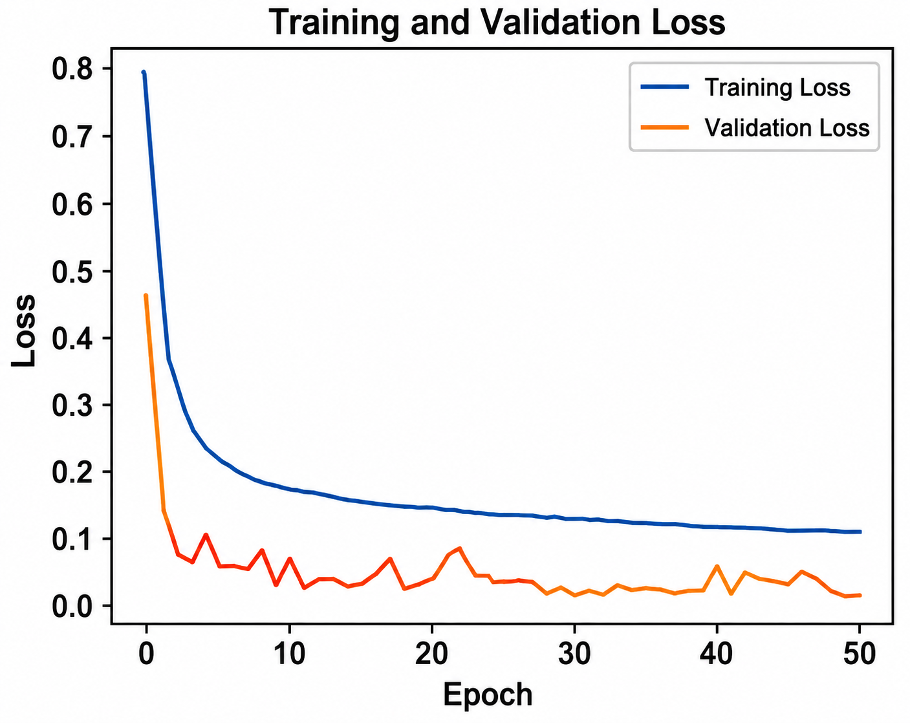
(a)
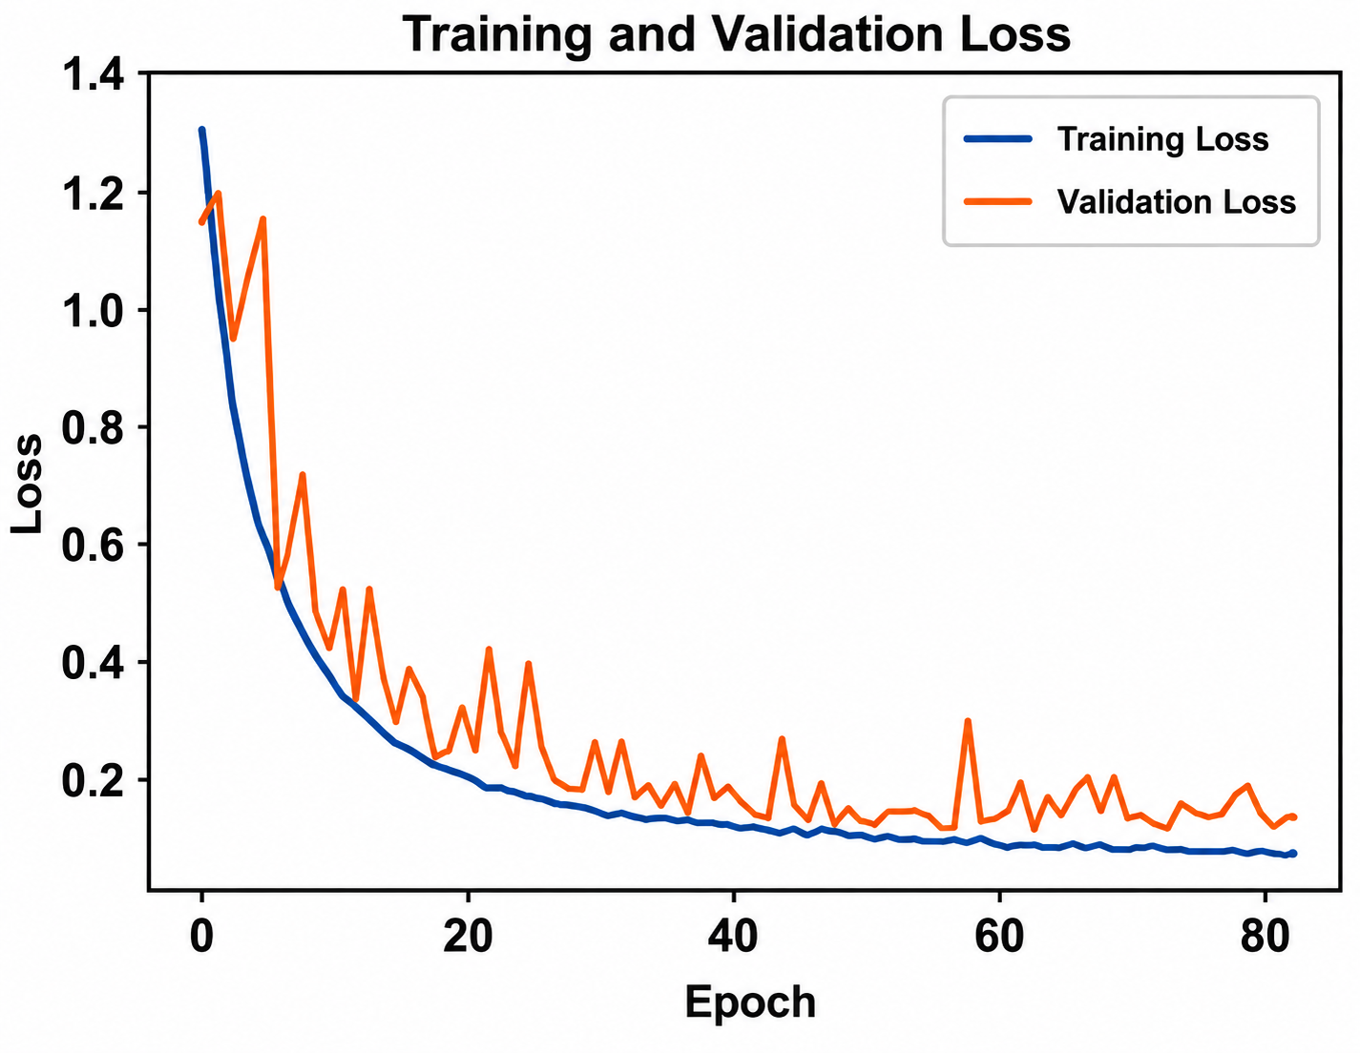
(b)
Fig. 5 (a) Training and validation loss for OCT2017 dataset (b) Training and validation loss for OCT-C8 dataset
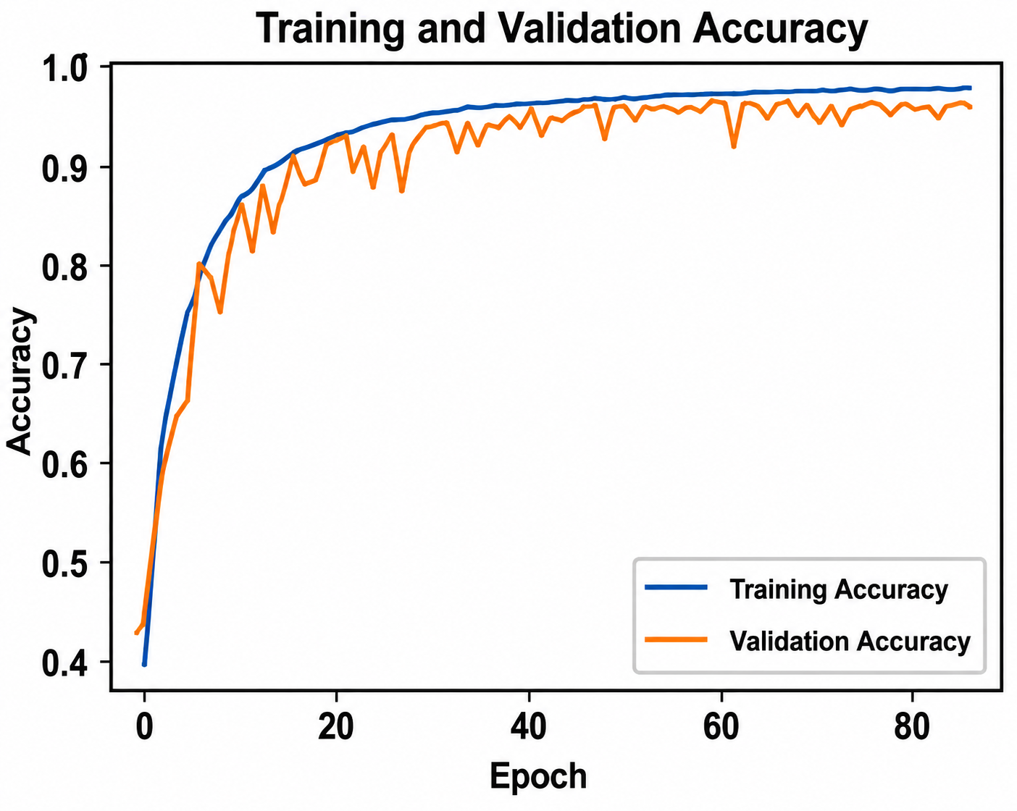
(b)
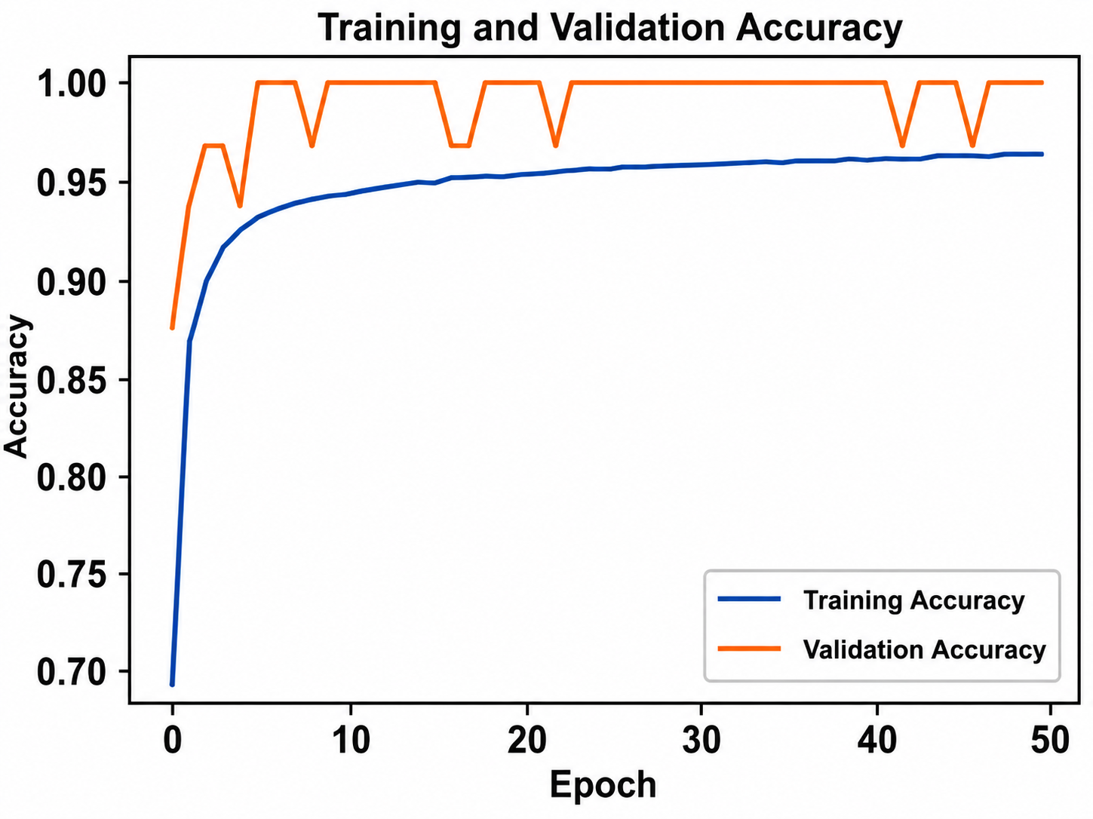
(a)
Fig. 6 (a). Training and validation accuracy for OCT2017 dataset (b). Training and validation accuracy for OCT-C8 dataset

Table 3 summarizes the class-wise classification performance of the proposed CNN-SE model on the OCT2017 and OCT-C8 datasets. On OCT2017, the model achieved an overall accuracy of 99%, with precision, recall, and F1-score values close to 1.00 across CNV, DME, Drusen, and Normal. For OCT-C8, the model obtained an overall accuracy of 97%, with the highest class-wise performance observed for CNV, DME, Drusen, and Normal, while AMD, CSR, DR, and MH also showed strong classification results. The macro- and weighted-average metrics were consistently 0.99 for OCT2017 and 0.97 for OCT-C8, indicating balanced performance across the evaluated classes despite the greater class diversity and morphological similarity in OCT-C8.

Table 3 Class-wise Classification Results of CNN-SE Model for OCT2017 and OCT-C8 datasets
 | OCT 2017 |  |  |  | OCT-C8
 | Precision | Recall | F1-score | Support | Precision | Recall | F1-score | Support
Class
AMD | Class Not Available |  |  |  | 1.00 | 1.00 | 1.00 | 350
CNV | 0.97 | 1.00 | 0.98 | 242 | 0.90 | 0.95 | 0.93 | 350
CSR | Class Not Available |  |  |  | 1.00 | 1.00 | 1.00 | 350
DME | 1.00 | 0.98 | 0.99 | 242 | 0.98 | 0.89 | 0.93 | 350
DR | Class Not Available |  |  |  | 1.00 | 0.99 | 1.00 | 350
Drusen | 0.99 | 0.98 | 0.99 | 242 | 0.94 | 0.93 | 0.94 | 350
MH | Class Not Available |  |  |  | 0.99 | 1.00 | 1.00 | 350
Normal | 1.00 | 1.00 | 1.00 | 242 | 0.92 | 0.97 | 0.94 | 350
Accuracy |  |  | 0.99 | 968 |  |  | 0.97 | 2800
Macro Avg | 0.99 | 0.99 | 0.99 | 968 | 0.97 | 0.97 | 0.97 | 2800
Weighted Avg | 0.99 | 0.99 | 0.99 | 968 | 0.97 | 0.97 | 0.97 | 2800

$Accuracy= \frac{TP+TN}{TP+TN+FP+FN}$ (17)
$Precision= \frac{TP}{TP+FP}$ (18)
$Recall= \frac{TP}{TP+FN}$ (19)
$F1-Score=2* \frac{Precision*Recall}{Precision+Recall}$ (20)

The model was evaluated using Eqs. (17), (18), (19) and (20)[36][37]

- Cross-Dataset Validation
To further examine domain robustness, the CNN-SE model was trained exclusively on OCT-C8 and evaluated directly on the OCT2017 dataset without retraining or fine-tuning, using the four shared diagnostic classes, namely CNV, DME, Drusen, and Normal. Across five repeated experiments with random seeds 11, 22, 33, 44, and 55, the model achieved an overall accuracy of 98.74 ± 0.11%, with weighted precision, recall, and F1-score of 98.75 ± 0.12%, 98.74 ± 0.11%, and 98.74 ± 0.11%, respectively. The corresponding macro-ROC-AUC of 0.9995 ± 0.0002 indicates consistent discrimination across the
Table 4. Cross-Dataset Testing Performance of the Proposed CNN-SE Model Across Five Random Seeds
Metric | Mean | SD | Mean ± SD
Accuracy | 0.987397 | 0.001132 | 98.74 ± 0.11%
Weighted Precision | 0.987460 | 0.001153 | 98.75 ± 0.12%
Weighted Recall | 0.987397 | 0.001132 | 98.74 ± 0.11%
Weighted F1-score | 0.987397 | 0.001141 | 98.74 ± 0.11%
Macro F1-score | 0.987397 | 0.001141 | 98.74 ± 0.11%
Macro ROC-AUC | 0.999545 | 0.000236 | 0.9995 ± 0.0002
Compatible Prediction Rate | 1.000000 | 0.000000 | 100.00 ± 0.00%

evaluated classes, while the 100.00 ± 0.00% compatible prediction rate confirms that all evaluated samples were mapped to the intended diagnostic categories across the repeated experiments. These findings provide evidence of stable cross-dataset robustness and generalization, summarized in Table 4

- Computational Efficiency and Inference Performance
The computational characteristics of the proposed SE-CNN were further examined against MobileNetV2, EfficientNetB0, and NASNetMobile using a consistent evaluation procedure as described in Table 5. With only 0.3748 M trainable parameters, 0.3670 G FLOPs, and 183.52 M MACs, the proposed network occupied just 1.54 MB and required an average of 9.40 ms to process an image. It also recorded the highest inference throughput among the evaluated models, reaching 106.4 images/s. These measurements show that the proposed architecture achieves its feature-recalibration capability without introducing the computational burden typically associated with larger networks. The resulting combination of a small model footprint and rapid inference indicates a favorable efficiency profile for retinal OCT classification, particularly in settings where computational resources may be limited.
In terms of diagnostic performance, the proposed CNN–SE model achieved 96.71% accuracy on the OCT-C8 test set, with a macro-AUROC of 0.9985, indicating strong discriminative capability. In the independent cross-dataset evaluation, where the model was trained on OCT-C8 and tested on OCT2017 across five random seeds as stated earlier, it achieved 98.74 ± 0.11% accuracy and 0.9995 ± 0.0002 macro-AUROC. The corresponding MCC (0.9832 ± 0.0015) and Cohen’s κ (0.9832 ± 0.0015) further demonstrate strong agreement and stable classification performance on the external dataset as presented in Table 6.

Table 5 Computational Efficiency Comparison of CNN Models
Model | Parameters (Millions) | FLOPs (G) | MACs (M) | Model Size (MB) | Peak Memory (MB) | Latency (ms/image) | Throughput (images/s)
Proposed SE-CNN | 0.3748 | 0.3670 | 183.52 | 1.54 | 0.00 | 9.40 | 106.40
MobileNetV2 | 2.2682 | 0.5342 | 267.09 | 9.21 | 0.0039 | 42.13 | 23.74
EfficientNetB0 | 4.0598 | 0.7083 | 354.16 | 16.29 | 0.0312 | 62.01 | 16.13
NASNetMobile | 4.2782 | 0.9983 | 499.15 | 18.95 | 0.0703 | 82.93 | 12.06

Table 6 Within-Dataset and Cross-Dataset Validation Results
Dataset / Evaluation | Test Set (#) | Accuracy (%) | Macro-AUROC | MCC | Cohen’s κ
OCT-C8 → OCT-C8 | 2,800 | 96.71 | 0.9985 | 0.9626 | 0.9624
OCT-C8 → OCT2017 | 968 | 98.74 ± 0.11 | 0.9995 ± 0.0002 | 0.9832 ± 0.0015 | 0.9832 ± 0.0015

- Ablation Study
To systematically assess the individual contributions of the SE blocks, data augmentation, and optimizer selection under the same training and testing settings, ablation research was carried out using the OCT2017 and OCT-C8 datasets.
At the beginning, a basic CNN model was trained without including SE blocks and without applying data augmentation. We call it Model A for the denotation which is shown in Fig. 1 in that SE blocks are not included. This architecture showed lower classification performance, especially for classes like CNV, DME, and Drusen where the features are quite similar. Since no augmentation was used, the training data lacked variation, which made it harder for the model to generalize well on unseen test dataset images. In the second model implementation: Model B, data augmentation was added while keeping the model architecture the same as Model A. With more varied training samples, the model was able to learn better patterns, which improved overall accuracy and reduced overfitting. There was also a clear improvement in recall, especially for minority classes and those with similar visual features.
While Model D indicated that substituting SGD for Adam led to slower convergence and somewhat reduced accuracy, Model C showed that adding SE blocks enhanced feature representation and classification performance, especially for structurally related retinal disorders. By strengthening feature learning, boosting generalization, and guaranteeing stable optimization, the suggested Model E—which combined SE blocks, data augmentation, and the Adam optimizer—achieved the best overall performance. The ablation findings verify that each element adds to the model’s efficacy, and when combined, they produce the most robust and well-balanced retinal OCT image. The results of the ablation study are briefly presented in Table 7.
To examine the contribution of the main components, the ablation results were analyzed through controlled pairwise comparisons using the configurations reported in the study presented by Table 8. Removing the SE blocks reduced OCT2017 accuracy from 97.9% to 96.2%, while adding augmentation improved the baseline from 96.2% to 97.8%; similarly, replacing SGD with Adam increased OCT2017 accuracy from 95.3% to 99.0% and OCT-C8 accuracy from 94.1% to 97.0%. These comparisons indicate that SE blocks, data augmentation, and optimizer selection contribute to the overall performance of the proposed model. Among the tested factors, the optimizer changes from SGD to Adam produced the largest observed improvement. Alternative SE reduction ratios, pooling strategies, and dropout rates were not included in the reported experiments and therefore no unsupported conclusions are drawn for these components.

Table 7 Ablation study of different model implementations
Model | SE Blocks | Data Augmentation | Optimizer | Accuracy (OCT2017) | Accuracy (OCT-C8)
Model A | No | No | Adam | 96.2% | 92.8%
Model B | No | Yes | Adam | 97.8% | 94.6%
Model C | Yes | No | Adam | 97.9% | 94.87%
Model D | Yes | Yes | SGD | 95.3% | 94.1%
Model E (Proposed Model) | Yes | Yes | Adam | 99.0% | 97.0%

Table 8 Component wise ablation study analysis (pp = percentage point)
Comparison | Component isolated | OCT2017 Accuracy Change | OCT-C8 Accuracy Change
Model A → Model B | Data augmentation | +1.60 pp | +1.80 pp
Model A → Model C | SE blocks | +1.70 pp | +2.07 pp
Model D → Model E | Optimizer (SGD → Adam) | +3.70 pp | +2.90 pp
Model C → Model E | Data augmentation | +1.10 pp | +2.13 pp

- Comparison with existing approaches
Table 9 presents a comprehensive comparison of the proposed model against existing state-of-the-art techniques evaluated on the OCT2017 and OCT-C8 datasets. This comparative analysis was conducted to contextualize the performance of the proposed CNN-SE architecture relative to previously published approaches, taking into account differences in network depth, parameter count, and optimization strategies employed across the literature. Such benchmarking is essential not only to validate the effectiveness of the proposed method but also to identify the specific architectural choices that contribute to performance gains over conventional CNN-based classifiers.
Existing CNN-based approaches applied to the OCT2017 dataset have reported classification accuracies ranging from 88.4% to 98.75%, with differences arising from network architecture, preprocessing, data augmentation, dataset partitioning, and evaluation protocols. Therefore, the accuracy values reported in the literature are considered reference values rather than strictly equivalent benchmark results. Within this context, the proposed CNN-SE model achieves 99.00% accuracy on OCT2017, demonstrating a strong performance while maintaining a comparatively lightweight architecture. Furthermore, the proposed model achieves 97.00% accuracy on the OCT-C8 dataset, an eight-class classification problem with greater inter-class similarity. The strong performance across both datasets provides additional evidence of the model’s generalization capability beyond a single dataset distribution. To further assess generalization across dataset distributions, cross-dataset validation was performed by training exclusively on the OCT-C8 training set and evaluating on the independent OCT2017 test set without additional training or fine-tuning. Across repeated runs, this evaluation achieved 98.74 ± 0.11% accuracy, 98.75 ± 0.12% weighted precision, 98.74 ± 0.11% weighted recall and F1-score, and a macro-ROC-AUC of 0.9995 ± 0.0002. These results provide additional evidence of consistent generalization beyond a single dataset distribution.

Table 9. Comparison with existing approaches
Publication Year | References | Approach | Acc (OCT2017 Dataset) | Acc (OCT-C8 Dataset)
2019 | L.Huang et al. [16] | Layer-guided convolutional neural network | 88.4
2020 | Le et al.[38] | Transfer learning | 87.20
2020 | Saraiva et al. [39] | Deep CNN architecture | 93.3
2021 | J Kim et al. [18] | Two binary CNN variants (Model 1 / Model 2 with high computational complexity) | 98.1/98.7
2023 | Hassan E et al [20] | Enhanced Optical Coherence Tomography (EOCT)-based framework | 97.47
2023 | Diao et al. [19] | CNN-based classification framework | 96.93
2023 | Michael Opoku et al. [40] | Capsule network integrated with contrast-limited adaptive histogram equalization | 97.7
2024 | Stanojevi´c, M et al. [24] | Deep convolutional neural network model | 95.55
2024 | Yang J et al. [23] | CNN, EfficientNet-V2, and ResNet-based ensemble architecture | 97.89
2025 | Dave and Domadiya et al. [28] | CNN with data augmentation, exponential learning rate decay, and hybrid max–average pooling | 98.75
2026 | Proposed Model | CNN enhanced with SE blocks, Adam optimization, and global average pooling | 99.00 | 97.00

- Explainable AI
Grad-CAM analysis was performed to examine the spatial features contributing to the predictions of the proposed CNN-SE model across the eight OCT-C8 classes, as illustrated in Fig. 7. The activation maps predominantly highlighted localized retinal regions associated with class-discriminative structural patterns, with stronger responses observed around abnormal retinal morphology in AMD, CNV, CSR, DME, DR, Drusen, and MH, whereas Normal samples generally exhibited more localized activation within the retinal layers. The concentration of activations around relevant retinal structures suggests that the learned convolutional representations capture spatially meaningful features for disease discrimination, particularly in cases involving subtle or overlapping morphological characteristics. Grad-CAM visualizations of representative misclassified samples further illustrate regions associated with the model’s incorrect predictions and provide additional insight into challenging class boundaries. Since Grad-CAM reflects the contribution of image regions to a model prediction rather than causal evidence of a specific pathological feature, these visualizations are interpreted as an explanatory analysis of the learned feature representations rather than a clinical localization method.

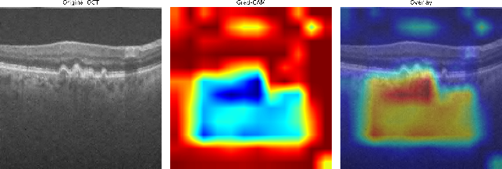  AMD | 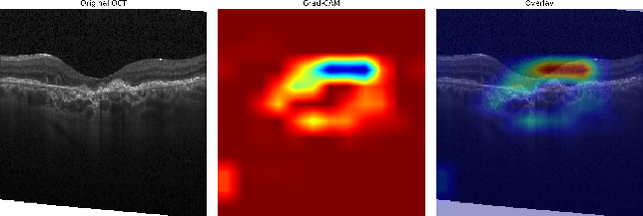  CNV
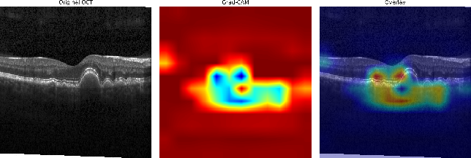  DRUSEN | 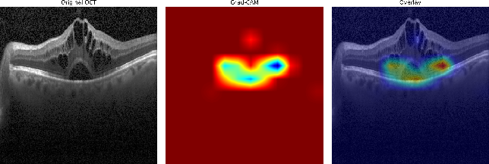  DME
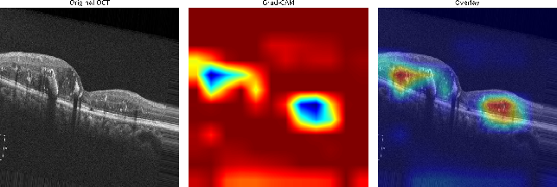  DR | 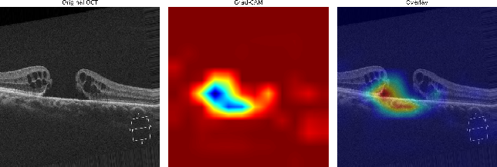  MH
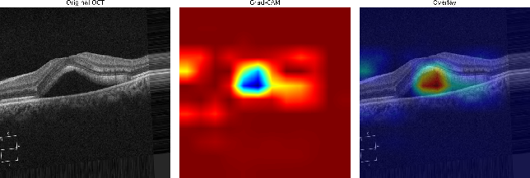  CSR | 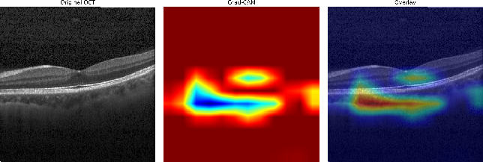  Normal
Fig. 7. Grad-CAM visualizations of representative OCT-C8 dataset

Conclusion and Future Work
This study presented a lightweight CNN-SE framework for retinal OCT image classification by integrating SE blocks, data augmentation, and the Adam optimizer. The proposed model achieved 99.00% and 97.00% accuracy on the OCT2017 and OCT-C8 datasets, respectively, while maintaining a compact computational profile. The five-seed cross-dataset evaluation further achieved 98.74 ± 0.11% accuracy and 0.9995 ± 0.0002 macro-ROC-AUC when the model trained on OCT-C8 was evaluated directly on OCT2017, providing evidence of robustness across the two dataset distributions. Grad-CAM analysis also provided visual insight into the image regions contributing to the model predictions.
Despite these encouraging findings, several limitations should be considered. The study relies on publicly available curated datasets, and no external hospital-based prospective validation was performed. Differences in OCT scanners, acquisition protocols, patient populations, and clinical settings may therefore affect model performance under real-world conditions. In addition, patient-level prospective testing was not available in the present study. Future work will focus on evaluating the proposed model using multi-center, hospital-based OCT datasets with diverse acquisition conditions, patient-level evaluation, and prospective clinical validation to establish its robustness and clinical applicability.
References (Heading 1, Arial 10, Bold, Blue)
[1] M. Asghari Oskoei and H. Hu, “Myoelectric control systems—A survey,” Biomed. Signal Process. Control, vol. 2, no. 4, pp. 275–294, Oct. 2007. (Arial 10)
[2] C. Fleischer and A. Wege, “Application of EMG signals for controlling exoskeleton robots EMG is better than force sensor,” Biomed Tech, vol. 51, pp. 314–319, 2006.
[3] J. V. V Basmajian and C. J. De Luca, “Chapter2: Apparatus, Detection, and Recording,” Muscles alive their Funct. Reveal. by Electromyogr., vol. 2, pp. 19–65, 1985.
[4] J. V Basmajian and C. J. De Luca, “Chapter1: introduction,” Muscles Alive their Funct. Reveal. by Electromyogr., pp. 1–18, 1985.
[5] G. R. Naik, S. Member, A. Al-timemy, and H. T. Nguyen, “Transradial Amputee Gesture Classification using an Optimal Number of sEMG Sensors : An Approach using ICA Clustering,” IEEE Trans. Neural Syst. Rehabil. Eng., vol. 4320, no. c, 2015.
[6] T. Triwiyanto, I. P. A. Pawana, and M. H. Purnomo, “An Improved Performance of Deep Learning Based on Convolution Neural Network to Classify the Hand Motion by Evaluating Hyper Parameter,” IEEE Trans. Neural Syst. Rehabil. Eng., vol. 28, no. 7, pp. 1678–1688, 2020.
[7] M. Atzori, M. Cognolato, and H. Müller, “Deep Learning with Convolutional Neural Networks Applied to Electromyography Data : A Resource for the Classification of Movements for Prosthetic Hands,” Front. Neurorobot., vol. 10, no. September, pp. 1–10, 2016.
[8] U. Côté-Allard, C. L. Fall, A. Campeau-Lecoursy, C. Gosseliny, F. Laviolettez, and B. Gosselin, “Transfer learning for sEMG hand gestures recognition using convolutional neural networks,” 2017 IEEE Int. Conf. Syst. Man, Cybern. SMC 2017, vol. 2017–Janua, pp. 1663–1668, 2017.
[9] T. Triwiyanto, O. Wahyunggoro, H. A. Nugroho, and H. Herianto, “Muscle fatigue compensation of the electromyography signal for elbow joint angle estimation using adaptive feature,” Comput. Electr. Eng., vol. 71, no. July, pp. 284–293, Oct. 2018.
[10] A. H. Al-Timemy, R. N. Khushaba, G. Bugmann, and J. Escudero, “Improving the Performance Against Force Variation of EMG Controlled Multifunctional Upper-Limb Prostheses for Transradial Amputees,” IEEE Trans. Neural Systdems Rehabil. Eng., vol. 24, no. 6, pp. 650–661, Jun. 2016.
[11] R. N. Khushaba, A. Al-timemy, S. Kodagoda, and K. Nazarpour, “Combined influence of forearm orientation and muscular contraction on EMG pattern recognition,” Expert Syst. Appl., vol. 61, pp. 154–161, 2016.
[12] E. Scheme, A. Fougner, Ø. Stavdahl, and A. D. C. Chan, “Examining the Adverse Effects of Limb Position on Pattern Recognition Based Myoelectric Control,” in 32nd Annual International Conference of the IEEE EMBS, 2010, pp. 6337–6340.
[13] Y. Geng, P. Zhou, and G. Li, “Toward attenuating the impact of arm positions on electromyography pattern-recognition based motion classification in transradial amputees,” J. Neuroeng. Rehabil., vol. 9, no. 1, p. 1, 2012.
[14] D. Yang, W. Yang, Q. Huang, H. Liu, and S. Member, “Classification of Multiple Finger Motions during Dynamic Upper Limb Movements,” IEEE J. Biomed. Heal. Informatics, vol. 21, no. 1, pp. 134–141, 2015.
[15] J. L. Betthauser, C. L. Hunt, L. E. Osborn, R. R. Kaliki, and N. V Thakor, “Limb-Position Robust Classification of Myoelectric Signals for Prosthesis Control Using Sparse Representations,” in Annu Int Conf IEEE Eng Med Biol Soc, 2016, pp. 6373–6376.
[16] L. Chen, G. Yanjuan, and L. Guanglin, “Effect of Upper-Limb Positions on Motion Pattern Recognition Using Electromyography,” in 2011 4th International Congress on Image and Signal Processing, 2011, pp. 139–142.
[17] Triwiyanto, O. Wahyunggoro, H. A. Nugroho, and Herianto, “An investigation into time domain features of surface electromyography to estimate the elbow joint angle,” Adv. Electr. Electron. Eng., vol. 15, no. 3, pp. 448–458, 2017.
[18] A. Phinyomark, P. Phukpattaranont, and C. Limsakul, “Feature reduction and selection for EMG signal classification,” Expert Syst. Appl., vol. 39, no. 8, pp. 7420–7431, 2012.
[19] R. N. Khushaba, S. Member, A. H. Al-timemy, A. Al-ani, and A. Al-jumaily, “A Framework of Temporal - Spatial Descriptors based Feature Extraction for Improved Myoelectric Pattern Recognition,” IEEE Trans. Neural Syst. Rehabil. Eng., vol. 4320, no. c, 2017.
[20] P. Geethanjali and K. K. Ray, “A Low-Cost Real-Time Research Platform for EMG Pattern Recognition-Based Prosthetic Hand,” IEEE/ASME Trans. Mechatronics, vol. 20, no. 4, pp. 1948–1955, Aug. 2015.
[21] A. Phinyomark and E. Scheme, “EMG Pattern Recognition in the Era of Big Data and Deep Learning,” Big Data Cogn. Comput., vol. 2, no. 3, p. 21, Aug. 2018.
[22] A. Hartwell, V. Kadirkamanathan, and S. R. Anderson, “Compact Deep Neural Networks for Computationally Efficient Gesture Classification From Electromyography Signals,” arXiv:1806.08641v2 [cs.CV], Jun. 2018.
[23] A. Sors, S. Bonnet, S. Mirek, L. Vercueil, and J.-F. Payen, “A convolutional neural network for sleep stage scoring from raw single-channel EEG,” Biomed. Signal Process. Control, vol. 42, pp. 107–114, Apr. 2018.
[24] C. Ieracitano, N. Mammone, A. Bramanti, A. Hussain, and F. C. Morabito, “A Convolutional Neural Network approach for classification of dementia stages based on 2D-spectral representation of EEG recordings,” Neurocomputing, vol. 323, pp. 96–107, 2019.
[25] T. Epelbaum, “Deep learning: Technical introduction,” in arXiv:1709.01412, arxiv.org, 2017, pp. 1–106.
[26] L. H. Smith, L. J. Hargrove, B. a. Lock, and T. a. Kuiken, “Determining the optimal window length for pattern recognition-based myoelectric control: Balancing the competing effects of classification error and controller delay,” IEEE Trans. Neural Syst. Rehabil. Eng., vol. 19, no. 2, pp. 186–192, 2011.

Author Biography (ARIAL 10, BOLD, H1)

Triwiyanto Triwiyanto (S’ 2015 - M ‘2024) received the B.S. degree in Physics (Instrumentation) from Airlangga University, in 1997, M. Eng. degrees in Electronic Engineering from the Institut Teknologi Sepuluh Nopember Surabaya, Indonesia in 2004, and the Ph.D. degree in Electrical Engineering from Gadjah Mada University,Yogyakarta, Indonesia, in 2018. Since 2005, he has been an Associate Professor with the Medical Electronics Technology, Health Polytechnic Ministry of Health Surabaya, Indonesia. Since 2015, he is an IEEE member. His current research interests include biomedical signal processing, rehabilitation engineering, machine learning, and surface electromyography (sEMG)-based physical human robot interactions. Currently, He has more than 100 documents on Scopus database (Arial 10)


Wahyu Caesarendra is an Assistant Professor at the Faculty of Integrated Technologies, Universiti Brunei Darussalam since October 2018. He received a Bachelor of Engineering degree from Diponegoro University, Indonesia in 2005. He worked in the Department of Mechanical Engineering, Diponegoro University from 2010 to 2018 as an Assistant Professor. He received New University for Regional Innovation (NURI) and Brain Korea 21 (BK21) scholarships for Master study in 2008 and obtained his Master of Engineering (M.Eng) degree from Pukyong National University, South Korea in 2010. In 2011, Wahyu Caesarendra was awarded of University Postgraduate Award (UPA) and International Postgraduate Tuition Award (IPTA) from the University of Wollongong. He received a Doctor of Philosophy (Ph.D.) Degree from the University of Wollongong in 2015.

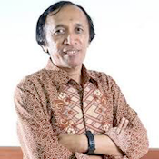
Mauridhi Hery Purnomo (IEEE Senior Member) received the B. S degree in power system engineering from Institut Teknologi Sepuluh Nopember Surabaya, Indonesia, in 1985. M. Eng and Ph.D degrees in Control Engineering and Intelligence System from Osaka City University Japan, in 1995 and 1998. He is a professor of Computer Engineering Department of Sepuluh Nopember Institute of Technology, Surabaya, Indonesia. He is an IEEE senior member. His research interests include control systems, artificial intelligent, application of neural networks and deep learning application for power system.
Each author is required to provide a cover image as shown example below

